**THE ELEGANCE AND BEAUTY OF THE FIVE PHASES**

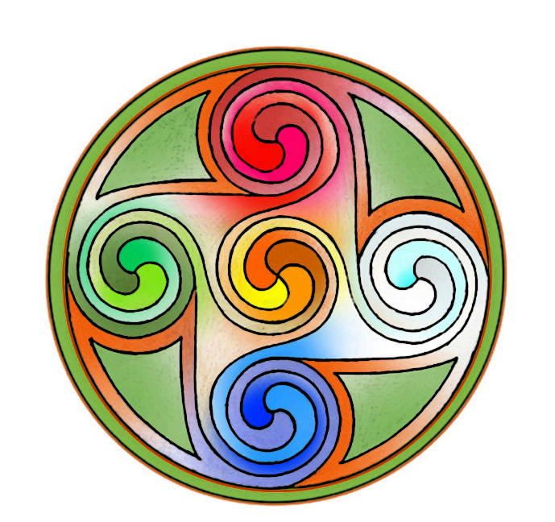

As requested by my inner wisdom and sense of knowing what I needed to move forward in my practise, I have had a quiet summer pottering in the garden and tending to my chickens, and of course, delving into my never ending study of herbal medicine. This is my meditation and is very nourishing and relaxing. Doing these simple tasks are my antidote to the busyness of life. This summer has been a very welcome pause, a still-point, which gave me the opportunityto review how I work and to consider what would best serve both my client’s health and wellbeing as well as my own.

I initially trained in Five Element (or Five Phases) acupuncture over 20 years ago. This system of traditional acupuncture is an ancient form of healing that is particularly suited to our modern world. It is very elegant in its simplicity, and the beauty lies in its ability to view the human being as an energetic being and to observe how these elements are expressing themselves within us. It mirrors the natural world and the changing seasons, encourages us to live in accordance with these natural laws and invites the person prioritise themselves over their symptoms.

My practise is in fertility, pregnancy, and women’s health, and although I have always viewed my clients through the Five Element lens, it is very easy for an acupuncturist to begin using ‘protocols’ which can become a ‘one fit for all’ type of practice if the whole person is not considered. For example, with assisted fertility, there are certain protocols (acupuncture points), which are used depending on which stage the couples are at in their treatment. I can see the value in this as these protocols are tried and tested with a solid rationale of why we are using them. They are also easier to research as they are less individualised. However, the energetic subtleties and how the flow of energy around the elements (the body and organ systems) is manifesting in the individual are missing. This is where the beauty of the Five Elements come in: as well as working alongside the cycle, we can work with the emotions, the physical and the psyche, and help to restore the natural state of balance at a time when the inevitable stressors threaten to overwhelm.

I am filled with gratitude for this system of medicine. It reminds me of our interconnectedness, and our sense of belonging in the natural world. It helps foster compassion as it is one of the most non-judgemental systems of medicine I have come across. I am so happy to be coming back home and to include this treasure in my acupuncture practise.